**SQL-CS-Task**

**(Muhammad Asyraf bin Muhammad Faiz) 1K6**

**Step 1:**

**CREATE DATABASE IF NOT EXISTS about_us;**

**USE about_us;**



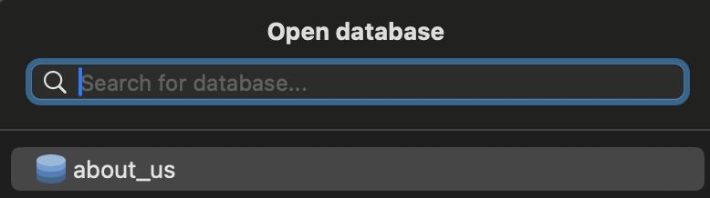

**Step 2:**

**CREATE TABLE about_us_as_well (**

**friend_number INT PRIMARY KEY AUTO_INCREMENT,**

**friend_name VARCHAR(100) NOT NULL,**

**hobby VARCHAR(100) NOT NULL,**

**school VARCHAR(100) NOT NULL,**

**first_encounter DATE NOT NULL**

**);**



**Step 3:**

**INSERT INTO about_us_as_well (friend_name, hobby, school, first_encounter)**

**VALUES ('Wan Muhammad Akiff', 'Playing games', 'KPPN', '2024-03-20')**



**Step 4:**

**UPDATE about_us_as_well**

**SET hobby = 'Sleeping'**

**WHERE friend_name = 'Wan Muhammad Akiff';**

**Step 5:**

**SELECT * FROM about_us_as_well**

**WHERE first_encounter > '2024-03-19';**





**Step 6:**

**SELECT hobby, school**

**FROM about_us_as_well**

**WHERE friend_name = 'Wan Muhammad Akiff';**



